**A2: Personal Nutrition Journey and Analysis**

Maddie Smith

FSU Coach, Florida State University

PET 5392: Coaching for Human Performance

Dr. Megan Buning

October 4th 2023

A2: Personal Nutrition Journey and Analysis

**Step 1: The Log**

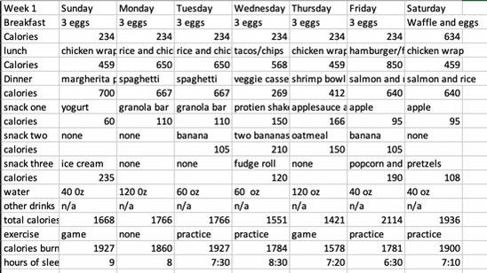

**Step 2: Week 1 Analysis**

Something that surprises me is how inconsistent I did with drinking water this past week. I have a goal of drinking at least three 30 oz bottles a day of water, to help with reminding myself to drink water. I am going to set an alarm on my phone for every other hour and see how that works for this next week. The consistency of my meals matched up to my daily intake which I think is a big strength of mine, not missing any meals. I am not a big breakfast eater so keeping it consistent helps me at least get a little fuel in my body before the day starts. I would like to add a carb to my breakfast and see how that affects my energy in the mornings. My sleep consistency is also all over the place, maintaining almost the same amount of hours slept in one night will overall help my mental state.

**Step 3: Nutrition Goals for Week Two**

Throughout my three goals I set, I believe they are all attainable through habitual behavior. In the six stages of change, action stands out the most to my goals. I have made it clear for myself since May of this year to completely lock in on my consistency to be a better athlete overall. These actions include maintaining the same breakfast everyday to get my protein in, which is three eggs and 30 0z of water to also maintain good water intake right when I wake up. The biggest goal I would like to keep putting into action is implementing water right when I wake up, possibly keeping a water bottle next to my bed that is filled can help solve this problem. Another goal that I would like to set for this next week is adding a carb to my breakfast. This can easily be done by adding a piece of toast or picking up some bagels from the snack shack the day before at Moore Fieldhouse. The last goal that I am focusing on is maintaining my sleep consistency, by doing this my circadian rhythm would be regulated and this promotes overall wellness. For this goal, setting an alarm for the same time to get ready for bed every night will help remind me to keep this goal consistent.

**Step 4: Week 2 log**

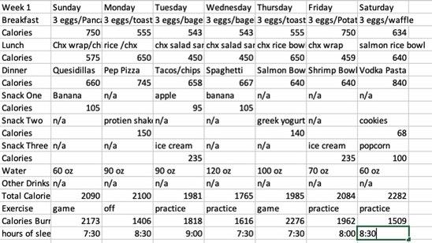

**Step 5: Stages of Change**

In step three I recognized my health goals were in the action stage of change. Since implementing a strict schedule for myself over this past summer I have seen my consistency rise and I have continued to stick to my plan to gain a better fitness outcome overall. I believe in these past two months since our fall soccer season started, I am starting to gradually move into the maintenance stage. As the season goes on, the six month mark of maintaining this consistency will hit and I will definitely be in the maintenance stage.

I give myself an eight out of ten rating for week two and the act of hitting my goals. The first goal I set was pretty easy to maintain, adding a carb for breakfast was easier since most of this past week we were traveling as a team and got breakfast delivered to us. My water intake was also on the positive side, with at least 60 oz of water a day I met my overall goal. Like I said we have been traveling since Wednesday morning so I have had multiple reminders to stay on top of my hydration. I think the biggest thing for me now is managing this while we aren't traveling. The last goal was my sleep consistency, this is why I gave myself an eight out of ten, rather than a solid ten overall. I wanted to stay in between a certain hour but did not maintain that.

The changes I made were very helpful in helping me maintain my goals. Setting a full water bottle next to my bedside at night helped me wake up, see that and want to drink it. The breakfast part was also easier since we have been traveling as a team and were given breakfast each morning. I have also been using Moore Fieldhouse snack shacks to my advantage, with free bagels and other good carbs, I have easily implemented them into my morning. The only thing I would change is to start making a before bedtime routine, doing this may help me stay consistent in what time I go to bed and what time I wake up as well.

One obstacle that could come in the way is traveling for soccer and still keeping the same sleep schedule. A big part of me not maintaining consistency is not being in a known environment. The ability to be in my own bed has significant factors on how I sleep. A game plan for this obstacle may be to bring my own blanket and pillow on away trips rather than use the hotels. Implementing a little home into the hotel bed may help me fall asleep faster and stay asleep.

This journey has helped me see the progress I have made since signing with Florida State this past April. I committed myself to being a better athlete, treating my body better and overall staying true to what my goals are in my soccer career. Everything outside of soccer matters just as much as the world inside of soccer.

**Part Two: Case Study of Tommy**

In Tommy's case I would recommend he eat a smaller meal since he wakes up only an hour prior to his practice. In the S&C textbook on page 204, it's listed that a pre-exercise meal should be smaller to be easily digested within an hour of the workout. I would recommend drinking at least 32 oz of water immediately upon waking up and continue to drink until practice starts to maintain hydration. For a food source, I would recommend something that can be digested quickly, like two eggs, some oatmeal and a banana for a quick energy boost according to Well and Goods article on food easily to digest. As his coach I would recommend Tommy eat a nutritious and big enough meal the night before to hold his stomach over until after practice the next morning since it is such an early practice. After practice, I would recommend drinking chocolate milk and doing some stretching to help promote recovery.